NVC Quick Start Guide
NVC 2.2.0 -- en
Contents
Open this document in Word to build the table of contents.

Before You Start
NVC converts video using FFmpeg. It needs two things before it can do anything: a source folder to watch, and a destination folder to write to.
Note
- ffmpeg.exe and ffprobe.exe must sit alongside the application files. NVC reports them as missing at startup if they are not there.
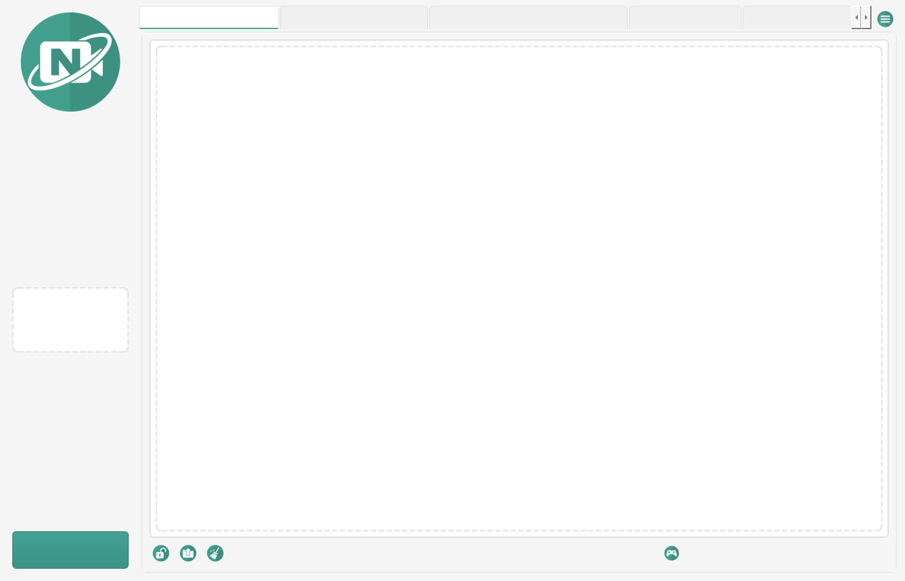
Figure 0. The NVC main window, with the conversion log and preview panel.

Your First Conversion
- Open Settings from the menu.
- Set a Source Folder -- the folder NVC watches for new video.
- Set a Destination Folder -- where converted video is written.
- Leave the output format at MP4 and the codecs at their defaults. These suit almost every case.
- Close Settings and click Start.
- Copy a video into the source folder. NVC queues it and converts it automatically.
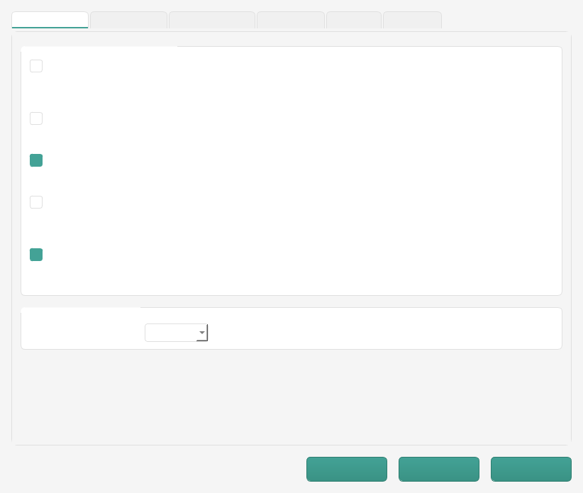
Figure 1. Settings, General tab: source and destination folders.
Progress appears in the conversion log. When the job finishes, the Converted Files tab records the result.

Settings Worth Knowing
Setting | Start with
Output Format | MP4. The most widely playable container.
Video Codec | libx264. Plays essentially everywhere.
Audio Codec | AAC. The standard partner for MP4.
Video Bitrate | Auto, unless you are targeting a specific file size.
Video Size | Auto, to keep the original dimensions.
Original Files | Keep Originals, until you trust the output.

Note
- NVC never overwrites an existing output. A second conversion of video.mp4 becomes video (1).mp4, exactly like a repeated browser download.

If Something Goes Wrong
- Read the conversion log first. FFmpeg usually says exactly what it objected to.
- Check the app is unlocked and monitoring is started.
- Confirm the file extension is one NVC supports.
- If GPU encoding is on, turn it off and retry on the CPU.
- For a failure with no message at all, set the NVC_LOG_LEVEL environment variable to DEBUG and reproduce it. NVC then logs the full traceback.
The Help manual covers every tab and setting in full, including the Lossless Editor, the Multi-Source Recorder, and the PC Report tool.

Glossary
Terms used throughout this guide. FFmpeg terminology is kept where it is what you will see in the conversion log.
Term | Meaning
Container | The file wrapper that holds video and audio streams, such as MP4, MKV or AVI. The container is what the file extension names; it is separate from the codec used inside it.
Codec | The scheme used to compress a stream. H.264 (libx264) and HEVC (libx265) are video codecs; AAC and MP3 are audio codecs.
FFmpeg | The command-line media tool NVC runs to do the actual conversion. Its output is what appears in the conversion log.
FFprobe | FFmpeg's inspection tool. NVC uses it to read duration, streams, codecs and other metadata without converting anything.
Stream copy | Rewriting media into a new container without re-encoding it. Fast and lossless, but only possible when the target container supports the existing streams. Also called remuxing.
Remux | Changing a file's container while keeping its streams untouched. See stream copy.
Transcode | Decoding and re-encoding a stream, which changes quality and takes significantly longer than a stream copy.
Keyframe | A frame stored in full rather than as a difference from its neighbours. Seeking and lossless trimming can only land cleanly on a keyframe.
GOP | Group of Pictures: the interval between keyframes. A shorter GOP makes scrubbing more precise at the cost of file size.
Bitrate | Data used per second of media, usually in kbps or Mbps. Higher bitrate generally means better quality and a larger file.
GPU encoding | Using dedicated video hardware (NVENC on NVIDIA, AMF on AMD, Quick Sync on Intel) to encode instead of the CPU. Much faster, with codec support depending on your drivers.
DirectShow | The Windows capture interface NVC uses to record from local devices. Sources are written as video=Device Name.
RTSP | A streaming protocol used by most IP and network cameras. Sources are written as a URL, such as rtsp://192.168.1.10/stream.
Retention period | How long NVC keeps an original file after a successful conversion before deleting it. Pending deletions survive a restart.
Redaction | Masking sensitive values such as licence keys, serial numbers, MAC addresses and user paths in a PC report before it is shared.

